**Team Members1:**

|  |  |  |  |
| --- | --- | --- | --- |
|  | Team Member ID | Team member name (**in Arabic**) | Grade |
| 1 | 20210064 | أحمد صلاح الدين أحمد سيد |  |
| 2 | 20210063 | أحمد تحسين صلاح الدين عبدالمجيد |  |
| 3 | 20210124 | أحمد هاني سعد محمد علي |  |
| 4 | 20210159 | إسلام مجدي محمد الصفي |  |
| 5 | 20210074 | أحمد عبدالغني أحمد عبدالغني |  |
| 6 | 20210081 | أحمد علي إبراهيم سليمان |  |
| 7 | 20210057 | أحمد سعدالدين محمد علي المراكبي |  |

Numerical:

General information about dataset:

|  |  |
| --- | --- |
| Name: | [Vehicle dataset](https://www.kaggle.com/datasets/nehalbirla/vehicle-dataset-from-cardekho) |
| Total number of samples | 7530 |
| Total number of training | 6024 |
| Total number of test | 1506 |

Linear Regression

I have features [‘ km_driven’,’ seller_type’,’ seller_type’,’ transmission’, ’ owner’,’ mileage’,’ engine’,’ max_power’,’ seats’]

My dataset before cleaning   
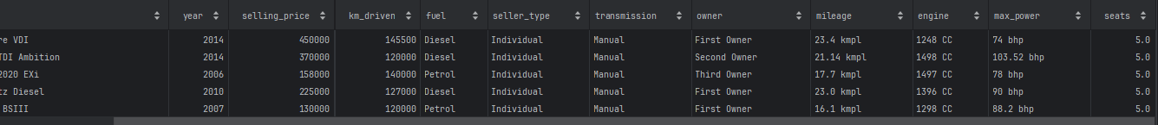

I applied encoding to convert categorical string values, such as 'diesel' and 'petrol', into numerical representations, with a subsequent addition of 1 to all values to avoid potential model confusion with zero. I then proceeded to transform specific features like 'mileage', 'engine', and 'max_power' into numerical values. To enhance data quality, I removed nullable values from the dataset.

Following this, I computed z-scores and selected specific rows based on the calculated scores. To enrich the dataset, I introduced a new column representing the age of the entries, I removed year and name columns.

So my dataset after cleaning is :

I have split my dataset to get train and test data then I applied standard scaler to normalize data and make_pipeline to make PolynomialFeatures and linear regression to work as one model then I fit my training data then predict   
I have calculated R-squared score :

The linear regression plot:

The cross validation plot:

Cross validation Score:



Linear regression Loss Curve:

K-NeighborsRegressor

I used same cleaned data I made before

R-squared score is :

K-NeighborsRegressor plot:

K-NeighborsRegressor Loss curve:

Conclusion:

From all the above we found that linear regression is better than K- NeighborsRegressor according to R-squared score.

Image:

General information about dataset:

|  |  |
| --- | --- |
| Name: | [Fruit](https://www.kaggle.com/datasets/moltean/fruits)360 |
| Total number of samples | 3239 |
| Total number of training | 2072 |
| Total number of test | 648 |
| Total number of validation | 519 |

Logistic Regression

Here we preprocessing and load our data

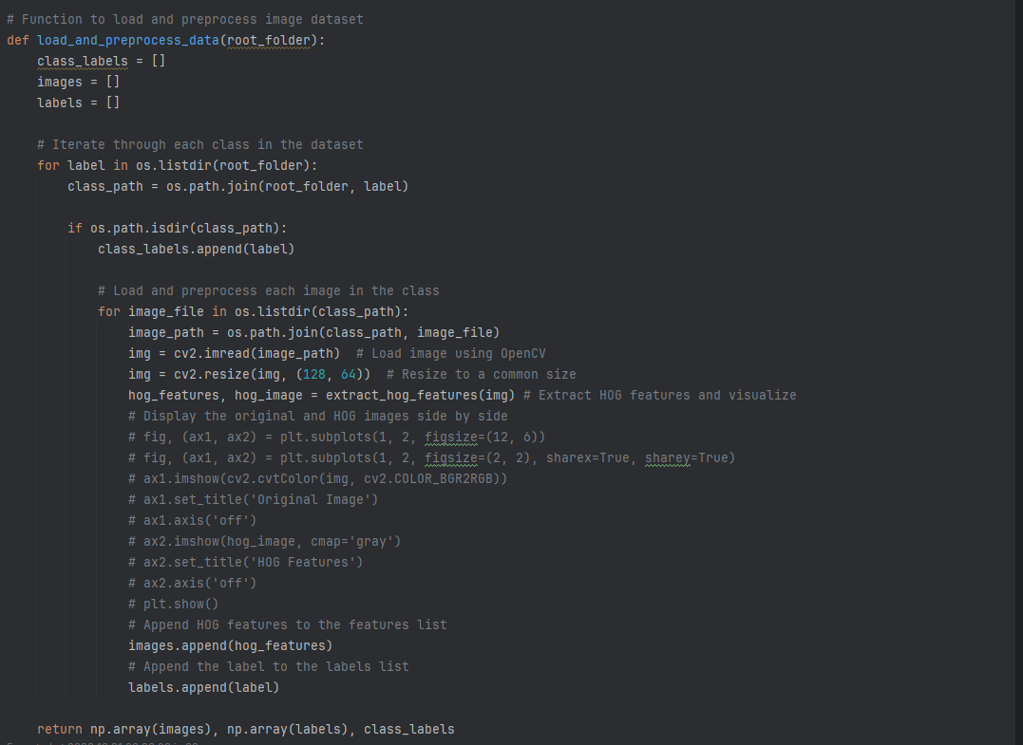

And we use HOG function to extract features

I split it into train, test, validation to see the loss curve

Confusion Matrix for Test Set

ROC Curve on Test Set

Classification Report

Predicts the test data correctly

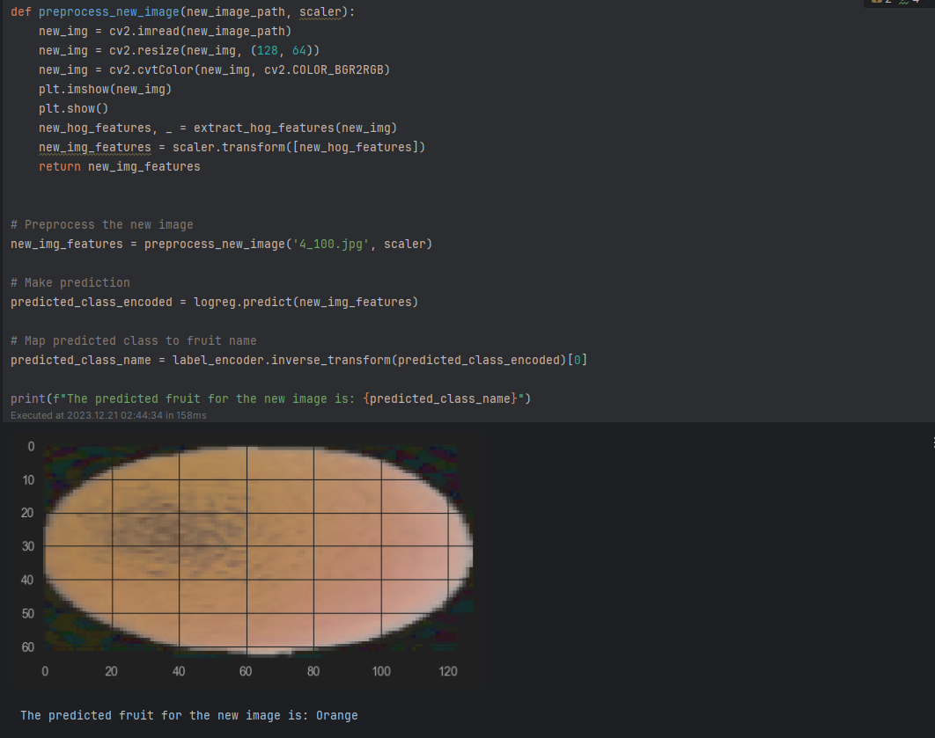

Kmeans

Here we don’t use HOG function we just flatten our image to convert it from 2D to 1D

We didn’t split the data into train, and test as in logistic regression

We used the elbow method to choose optimal K

Before using Kmeans we used PCA to reduce our dimensionality (features)

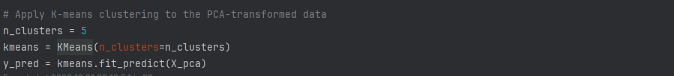

We used 5 clusters as we have 5 different classes of fruits

And here is the Kmeans Clustering

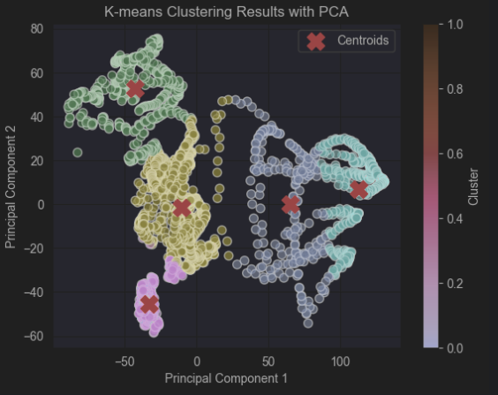

Here we calculated the silhouette and intertia

